|  |
| --- |
| Student Name: Owen Kerrisk  Student Number: A00301793  Student Signature:  Mentor: Dr. Brian Lee  ***Assignment 1- Penetration Testing using Kali & Metasploit***  Date Submitted: 20/03//2022 |

**Assignment 1 – Penetration Testing using Kali & Metasploit**





Cloud and Computer Security

2022

Table of Contents

Introduction 3

Task 1 - Network Scanning 4

Exercise 1.1: NMAP network scanning 4

Exercise 1.2: Scan automation using Legion 11

Task 2 Exploiting the Unreal IRC server 15

Exercise 2.1: Exploiting UnrealIRCd 15

Exercise 2.2 – Start HTTP webservice 22

Task 3 – Gaining Root Access 23

Exercise 3.1 – Identify and acquire kernel vulnerability 23

Task 4 – Cracking the passwords 28

Exercise 4.1 – Acquire the passwords 28

Exercise 4.2 – Deciphering the password 30

Task 5 – Login into Ubuntu Metasploit 31

Task 6 - MAPPING TO ATT&CK 33

Definition: 33

Tactics, techniques, and sub-techniques: 33

Task 7 - ATT&CK Technique Countermeasure 35

ATT&CK Matrix: 35

Conclusion 37

References 38

# Introduction

Computer and Cloud security is vital for many organisations in today’s world. Cloud service providers and corporate cloud service customers must undertake extensive preparations to act against cyberthreats before it's too late, and to recover from a wide variety of harmful cyberactivity’s when such threats succeed, to preserve organizational competitiveness [1]. While cloud-based solutions are appealing for organisations as it allows them to cut down on significant costs. However, it does come with some concerns due to its scaling, privacy and security. These are just some factors for some hesitations and issues relating to the adaptation of it [2].

This report will focus on penetration testing using both Kali and Metasploit. The goal is to complete each assigned task given. I will be focusing on the following;

* Network Scanning
* Exploiting the unreal IRC Server
* Gaining root access
* Cracking the passwords
* Logging into ubuntu Metasploit
* Mapping to Att&ck
* Att&ck Technique Countermeasures

All of these labs were completed on Oracle Box Virtual Machines which will demonstrate all my work I completed throughout this assignment.

# Task 1 - Network Scanning

## Exercise 1.1: NMAP network scanning



**ANS: nmap -sn 10.0.2.0/24**

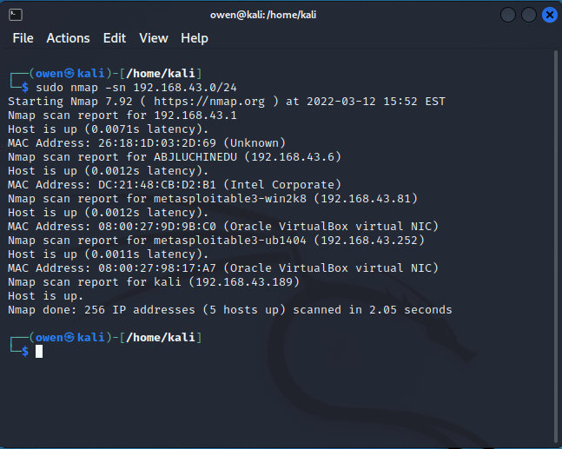



**ANS: sudo nmap -Pn -PS 192.168.43.252**

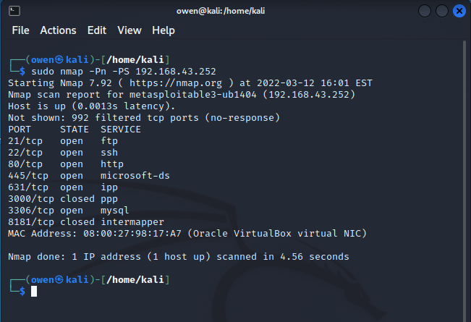



**ANS: sudo nmap -Pn -PS -p1-65535 192.168.43.252**

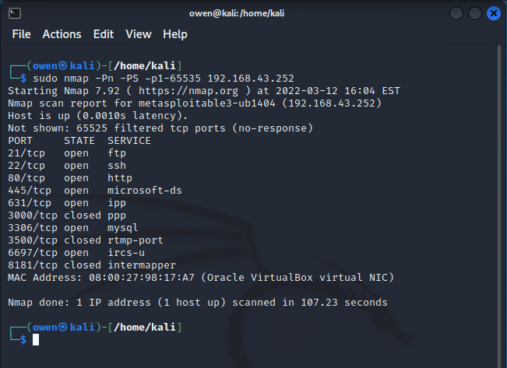

From the second scan carried out, the major difference with the previous scan has to do with the addition of two newly discovered ports, 3500(rtmp-port) and 6697(ircs-u)



**ANS: For Linux VM: sudo nmap -O -sV 192.168.43.252**

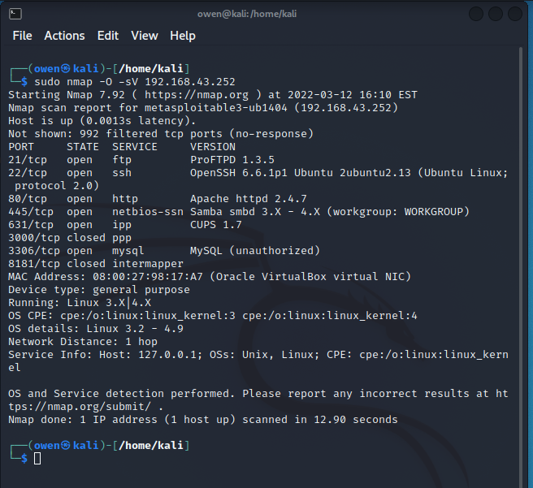

**For Windows VM: sudo nmap -O -sV 192.168.43.81**

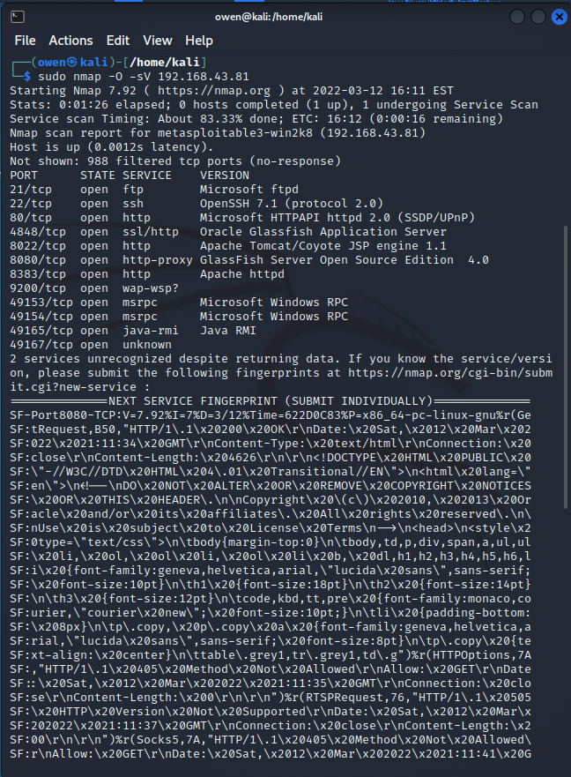

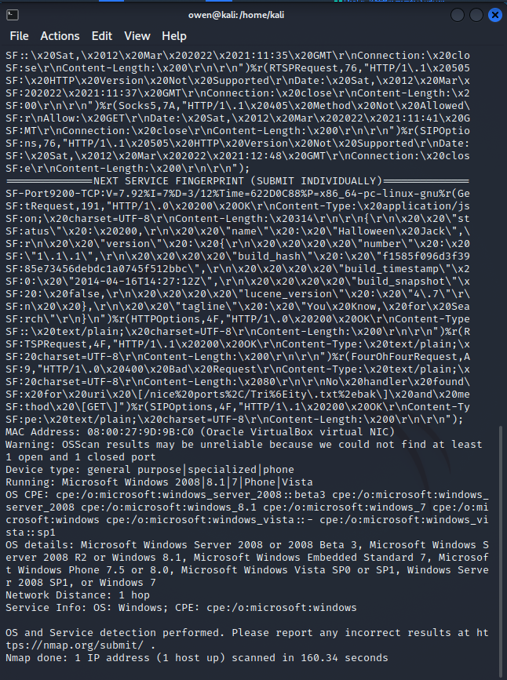

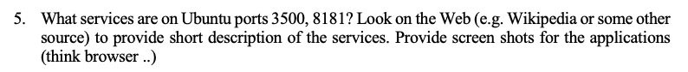

**ANS:**

**Port 3500:** Also known as the RTMP port, RTMP stands for Real-Time Messaging Protocol. It is a TCP based protocol used to stream audio, video and other kinds of data over a network. RTMP is capable of low-latency streaming, which is a major plus for broadcasters who are streaming major events in real-time. It is also known for its minimal buffering, which truly enhances the user experience.

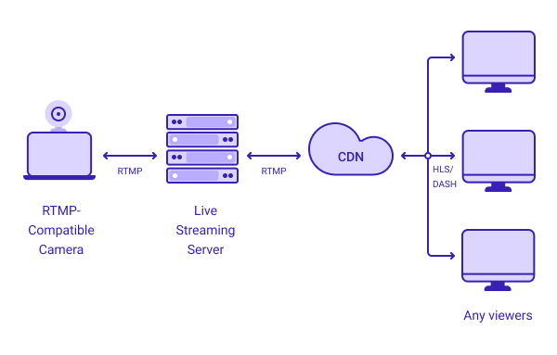

**Port 8181:** Also known as the intermapper port, it is a network monitoring and alert service that is used to monitor the state of devices and servers in a network. The intermapper core service functionality gathers data about a network and provides polling, alerting, notifications etc about its operations

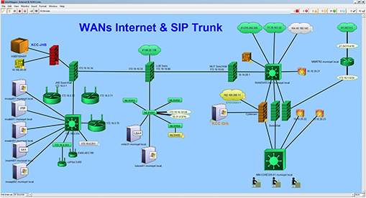

## Exercise 1.2: Scan automation using Legion

1. Start a scan on the Ubuntu host

**ANS:**

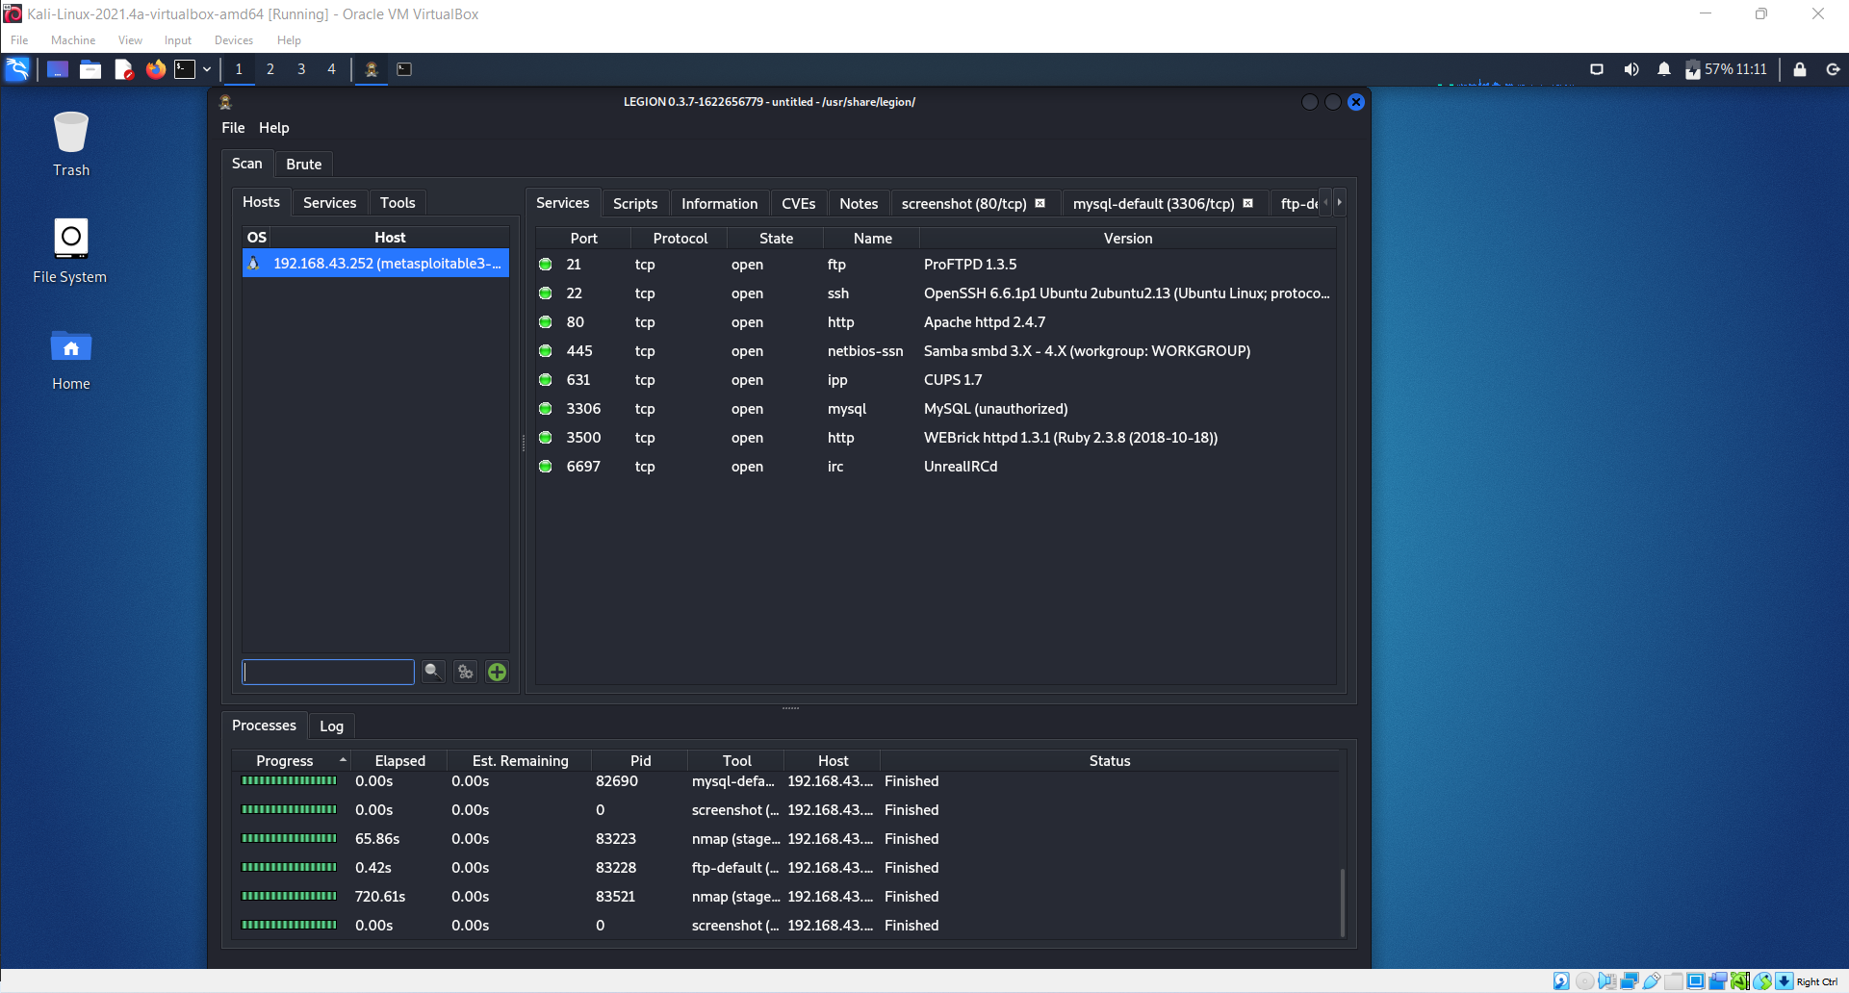

1. Show the list of ports and services:

**ANS:**

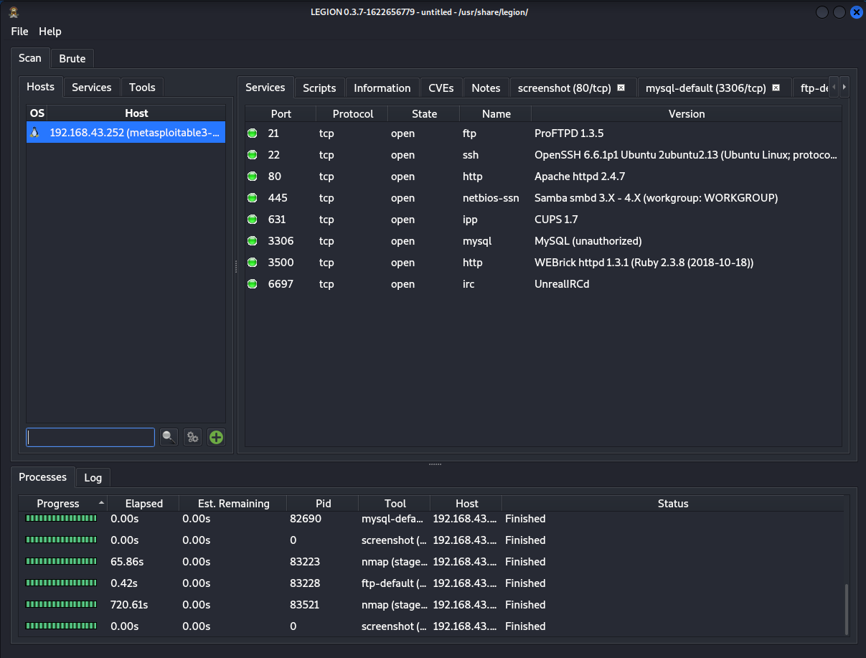

1. Show the screenshot for port 80

**ANS:**

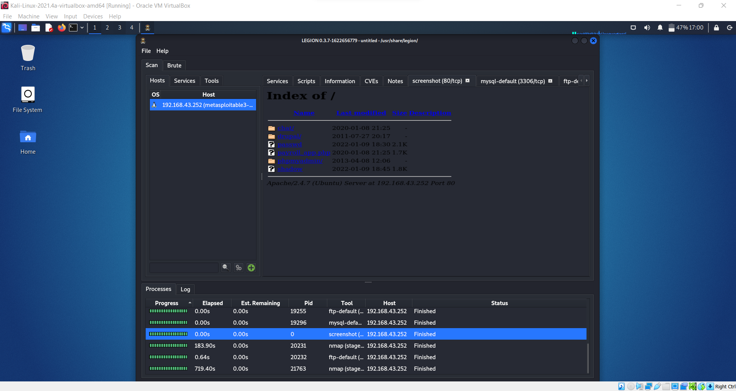

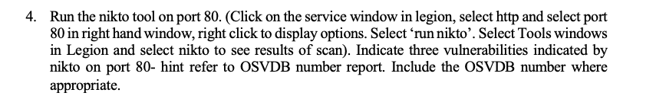

**ANS:**

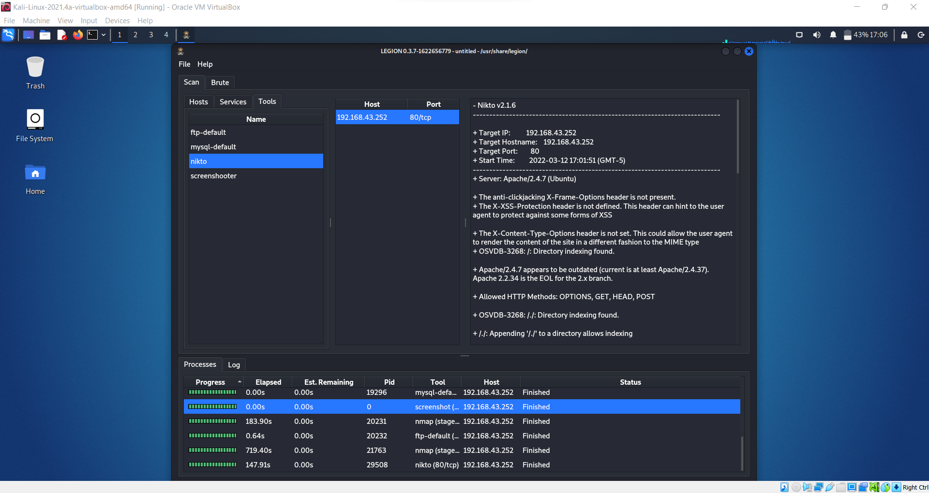

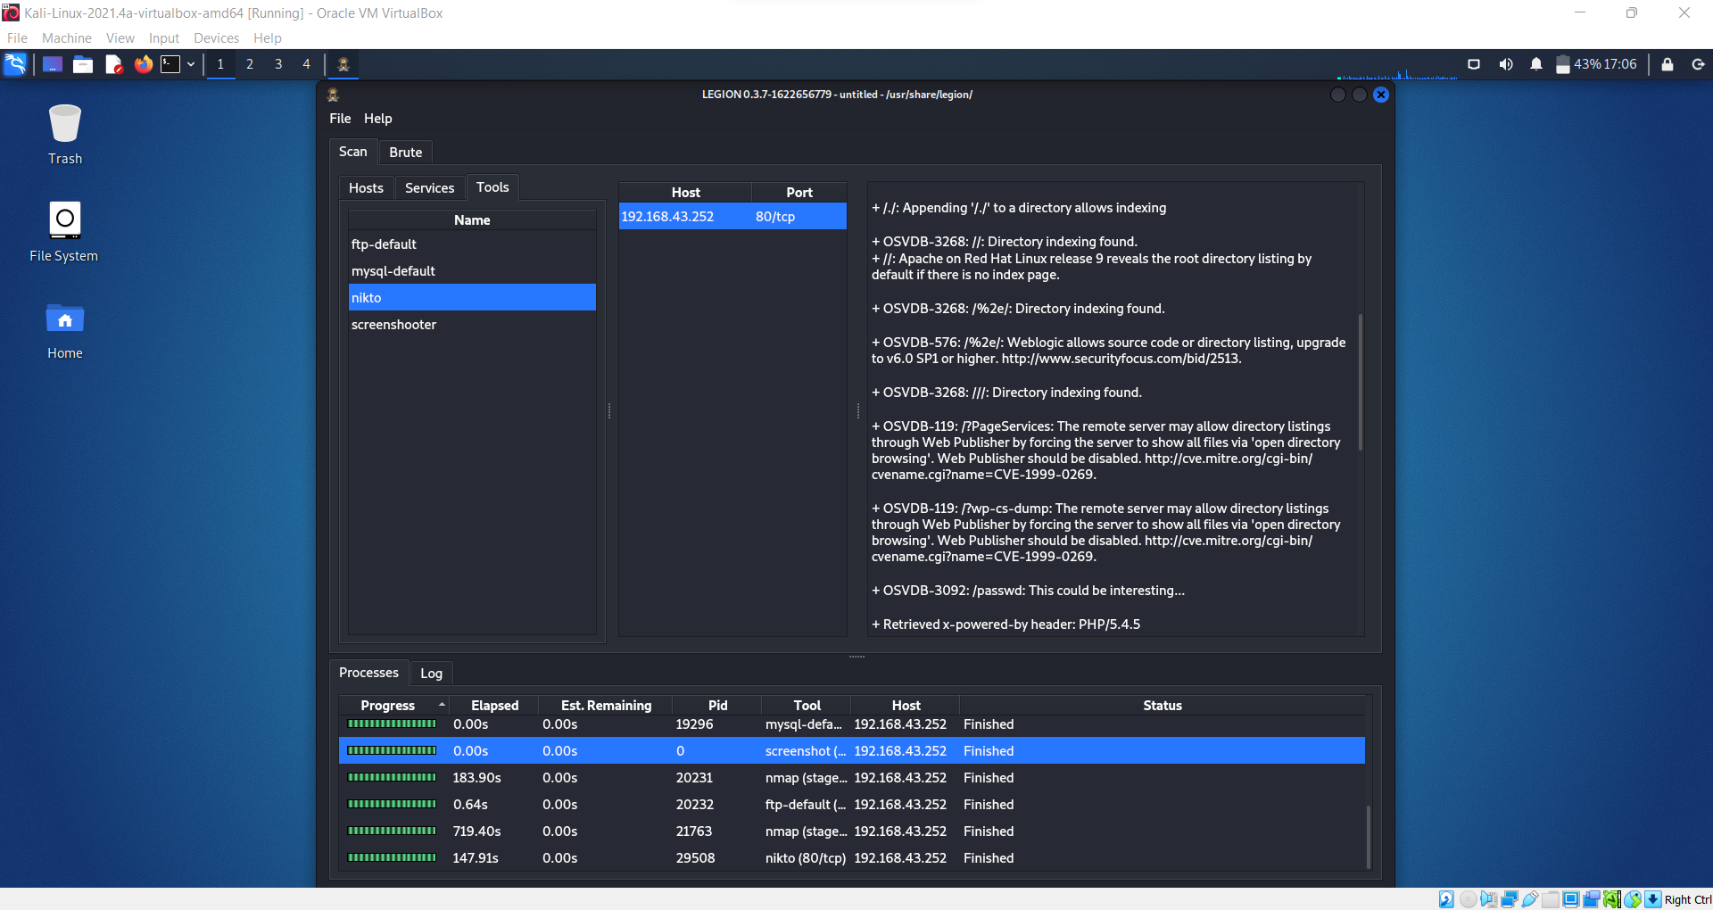

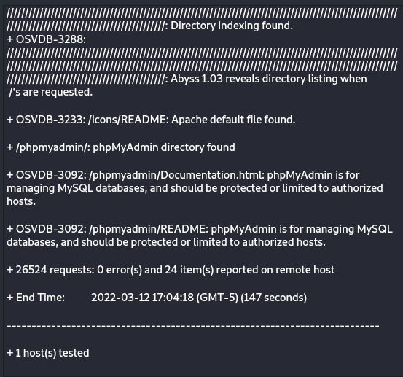

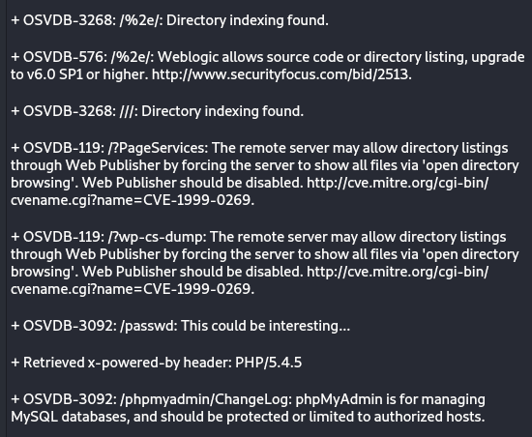

1. Grab the screenshot for port 3500.

**ANS:**

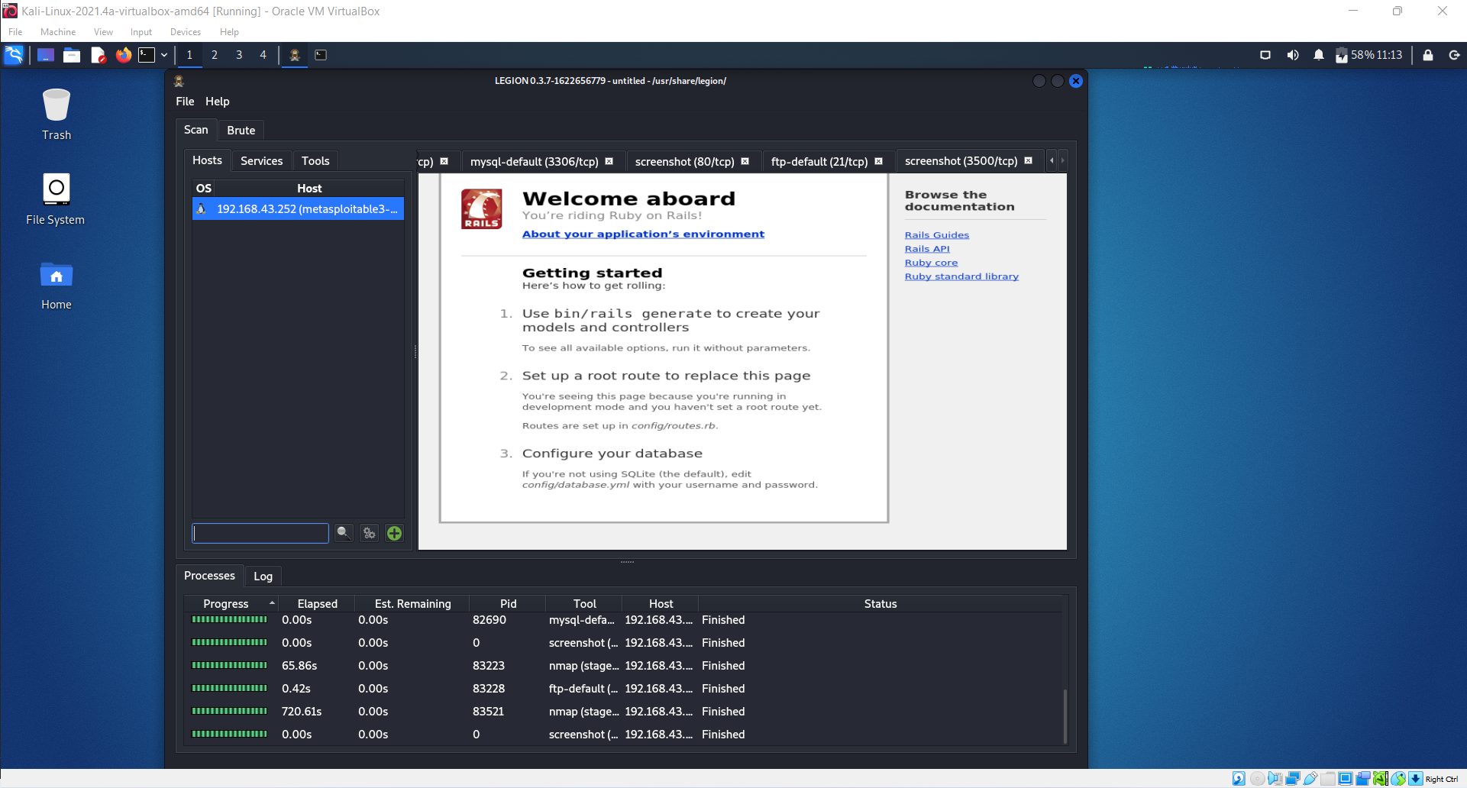

# Task 2 Exploiting the Unreal IRC server

## Exercise 2.1: Exploiting UnrealIRCd



**ANS:**

**IRC** stands for Internet Relay Chat, it is a protocol for real-time text messaging between internet-connected computers. The IRC protocol is built on the client-server concept and is well-suited to being dispersed across several computers [3]. Although it enables private messaging between two users, data transmission, and other server-side and client-side commands, it is mostly used for group discussion in chat rooms called "channels." An IRC client or a web interface that links you to IRC servers is required to connect and talk with other IRC users. Hundreds of IRC channels (conversation areas) are maintained on servers throughout the world, where users send messages to others on the same channel who are interested in the same subject. Client IRC applications provide graphical interfaces that make it easier to log on and view active channels, as well as send and receive messages.

**Unreal IRCd** is an Open Source IRC Server. It is a highly advanced IRCd with a strong focus on modularity, an advanced and highly configurable configuration file. Key features include SSL, cloaking, its advanced anti-flood and anti-spam systems, swear filtering and module support.



**ANS:**

**Version: 3.2.8.1**

**Port: 6697**



**ANS:**

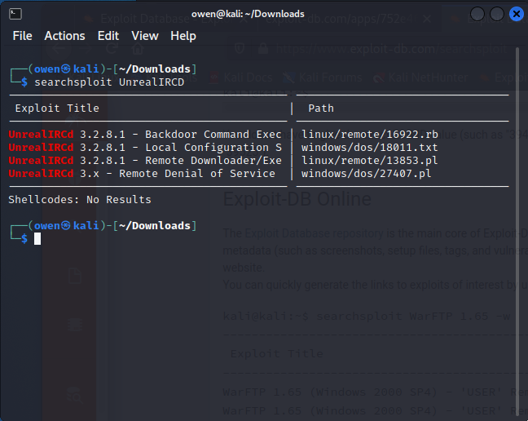



**ANS:**

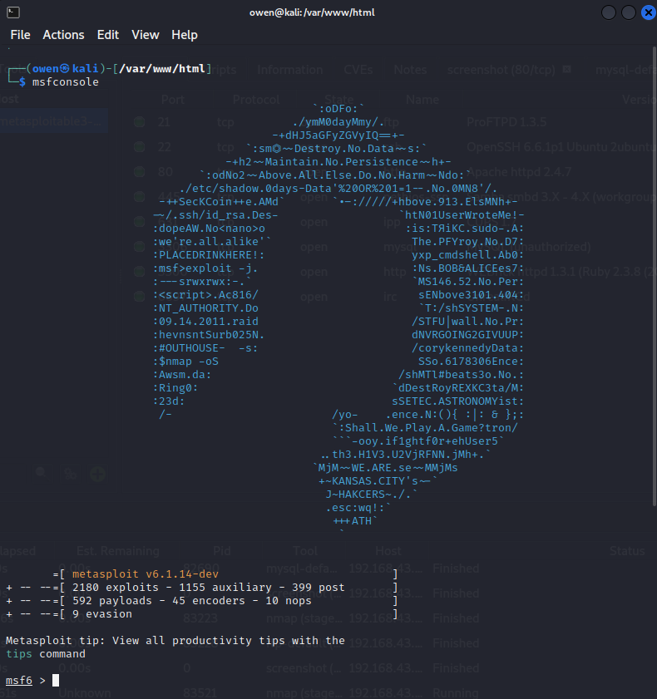



**ANS:**

**CVSS score: 7.5**

**CVE number: CVE-2010-2075**

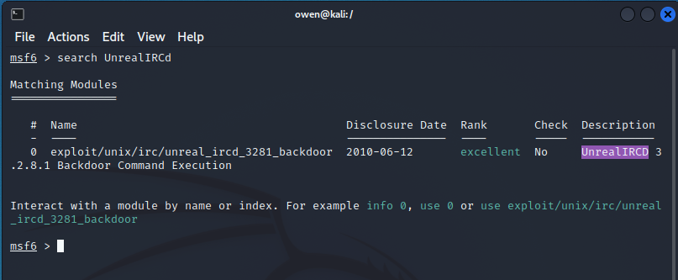

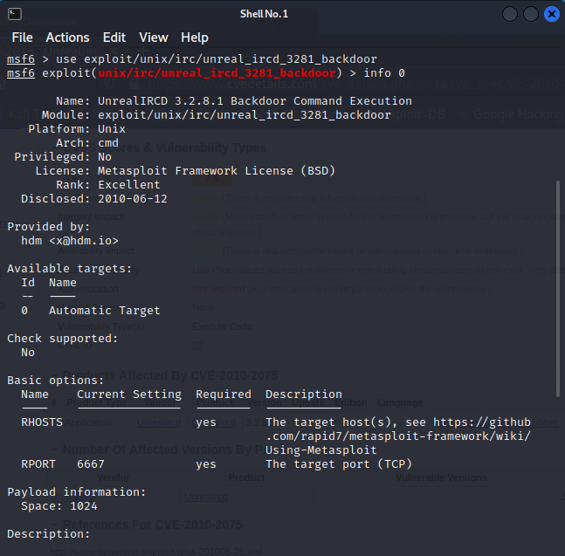

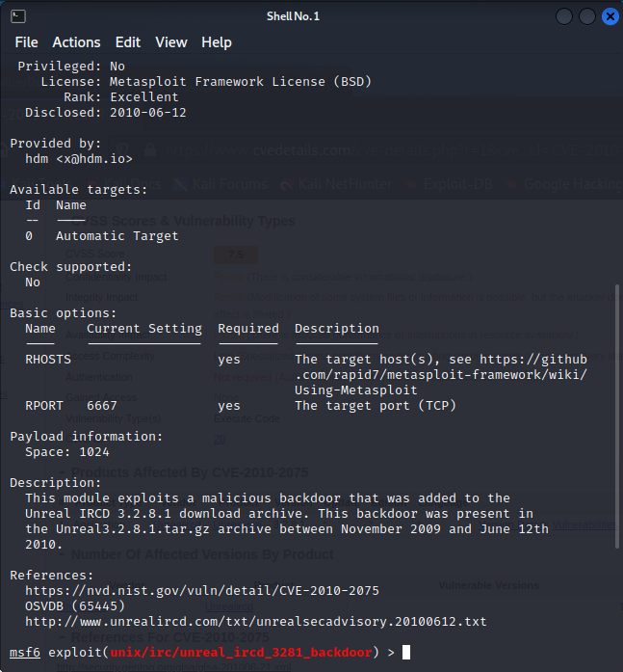



**ANS:**

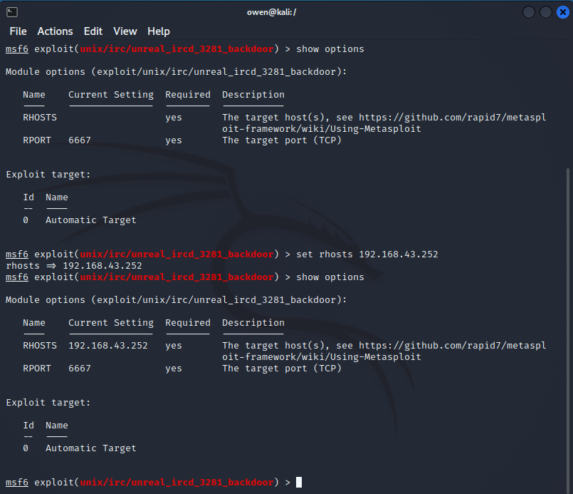



**ANS:**

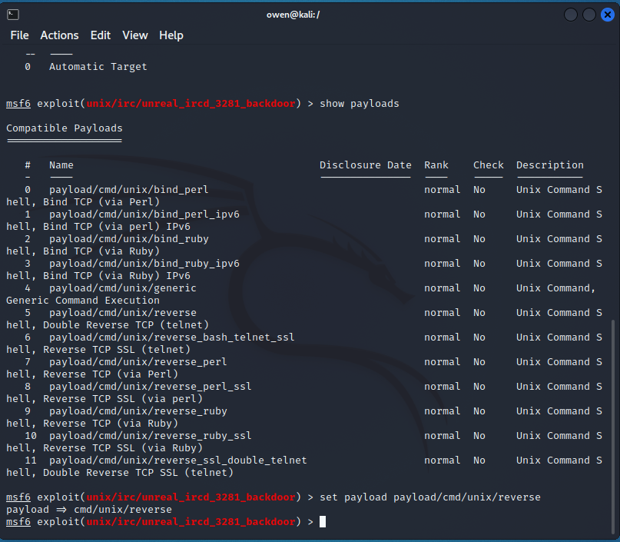



**ANS:**

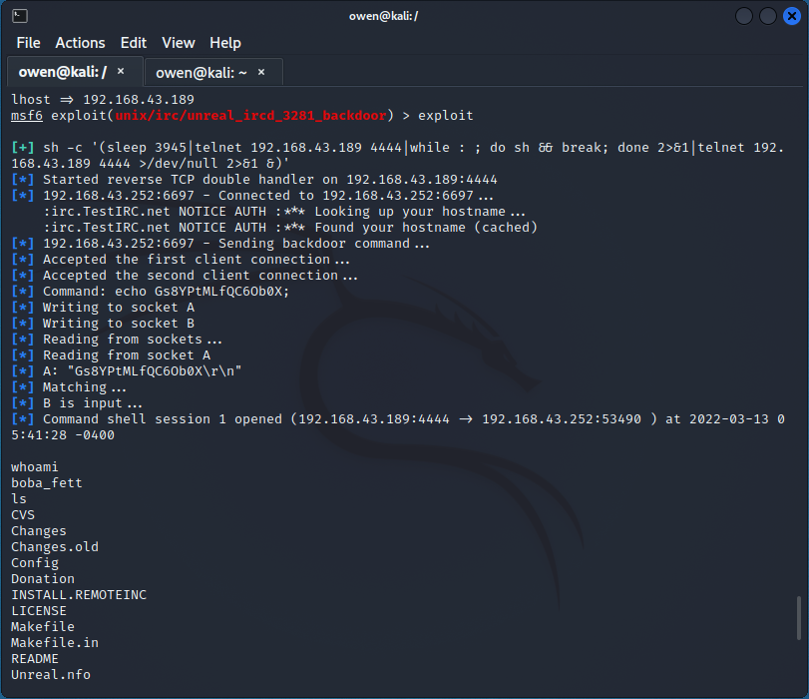

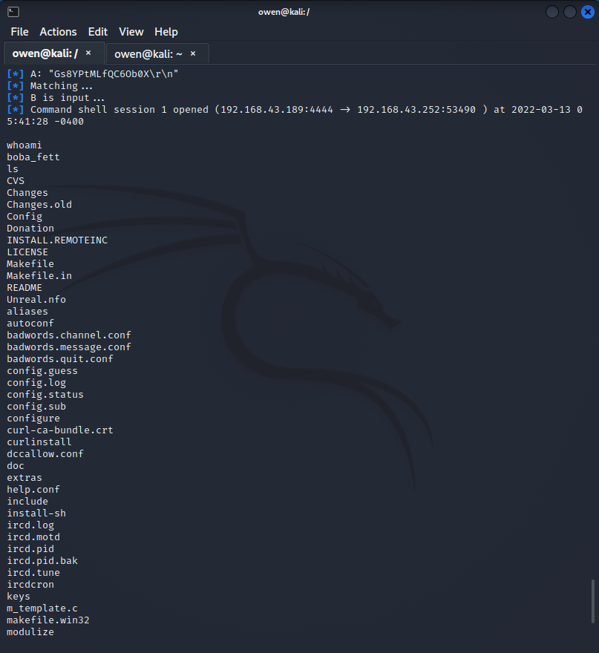

## Exercise 2.2 – Start HTTP webservice



**ANS:**

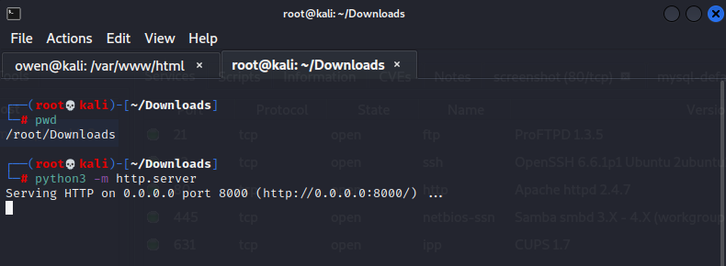

## 

# Task 3 – Gaining Root Access

## Exercise 3.1 – Identify and acquire kernel vulnerability



**ANS:**

**The kernel is 64-bit**

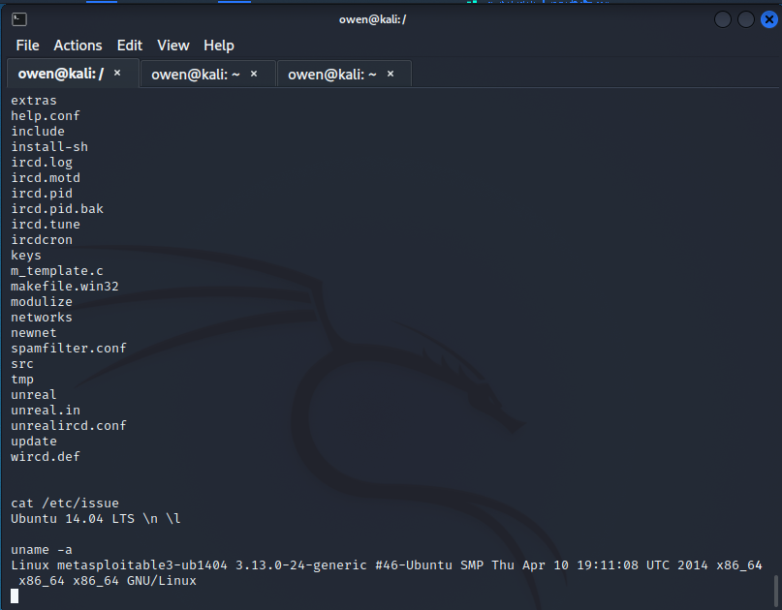

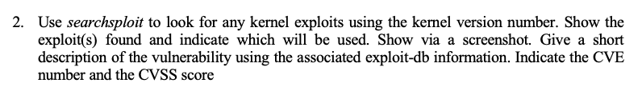

**ANS:**

**CVE number: CVE-2010-2075**

**CVSS score: 7.5**

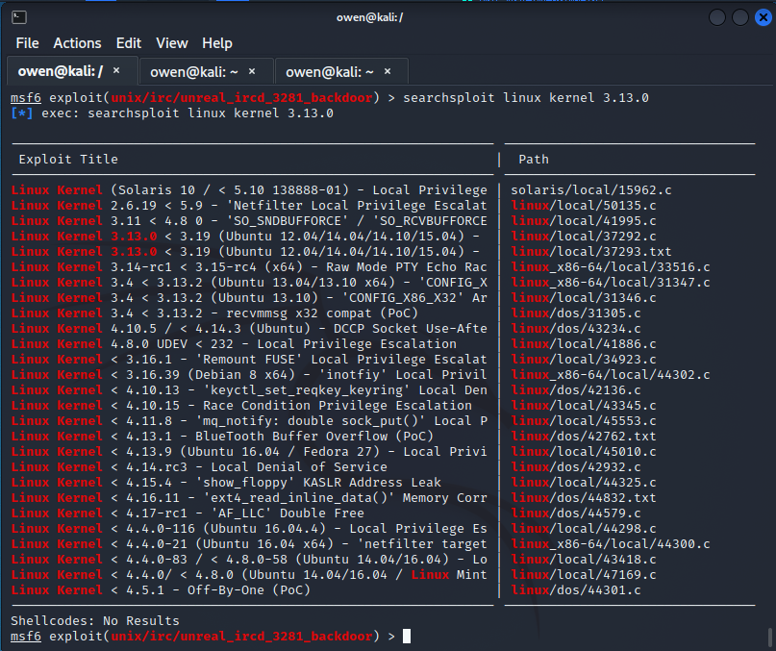

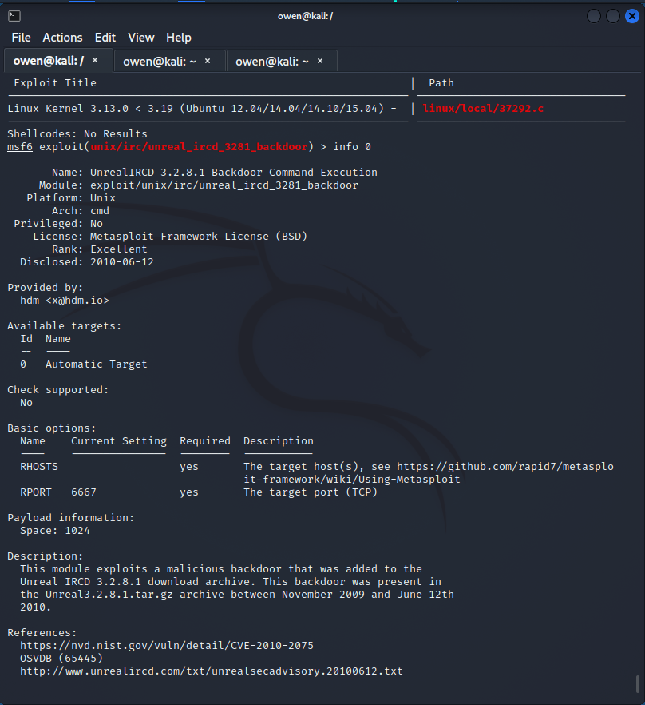



**ANS:**

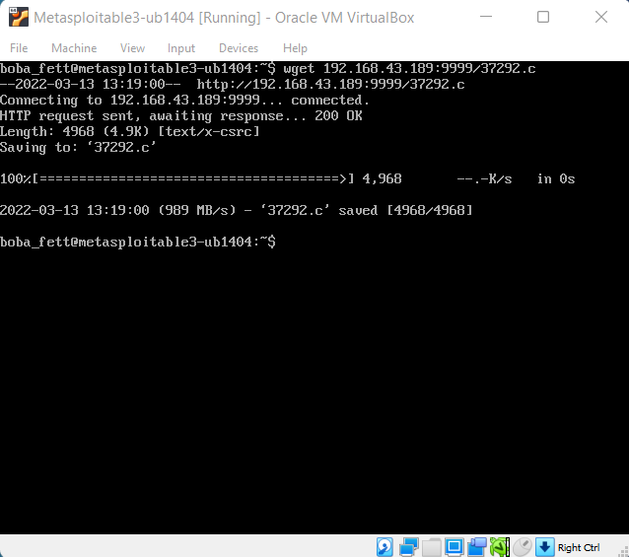

1. Follow the instruction in the C file to run the exploit.



**ANS:**

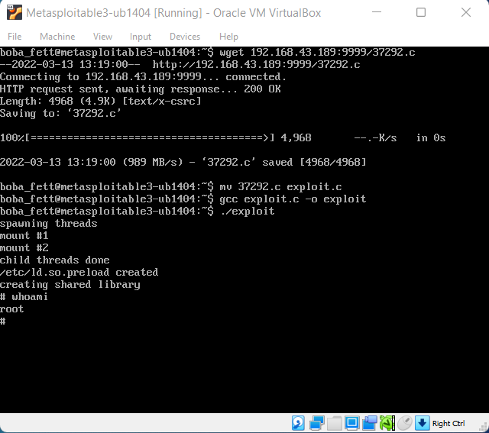

# Task 4 – Cracking the passwords

Exercise 4.1 – Acquire the passwords

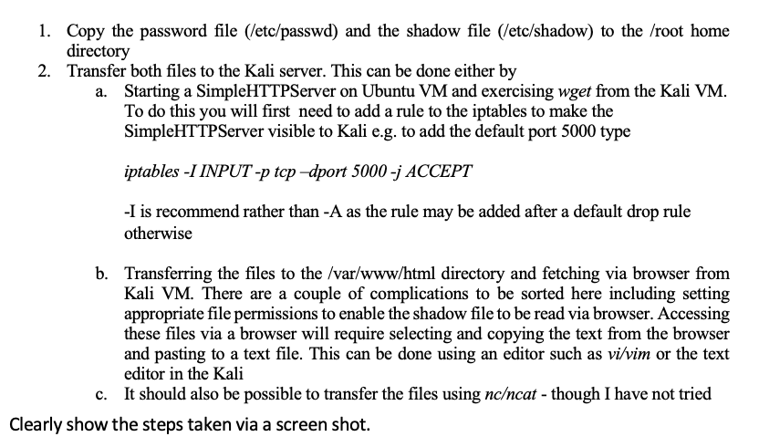

**ANS:**

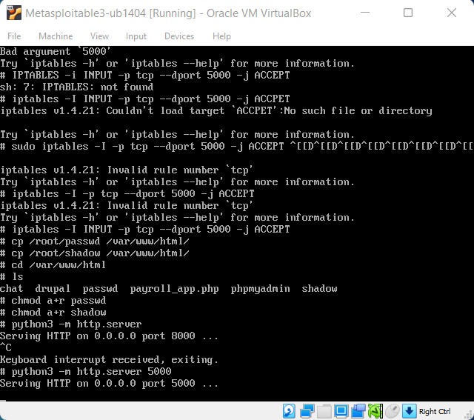

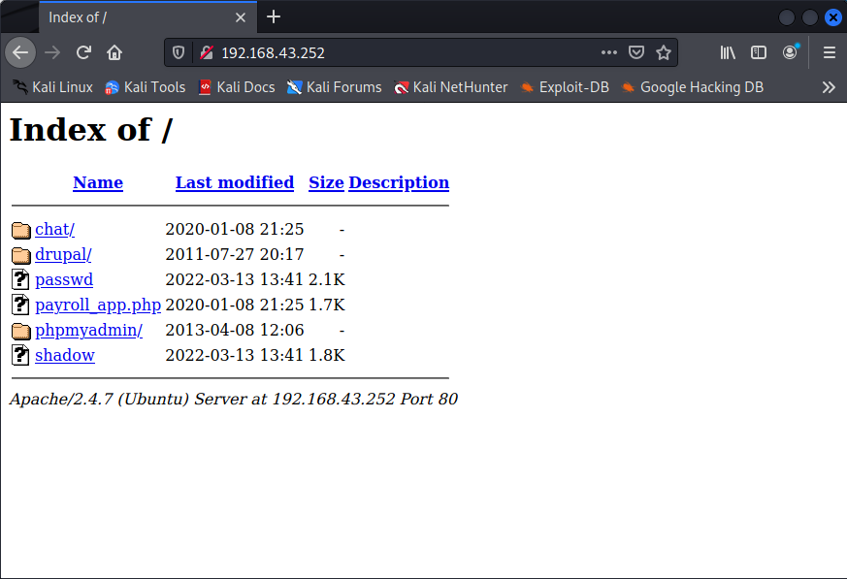

## **Exercise 4.2** – Deciphering the password

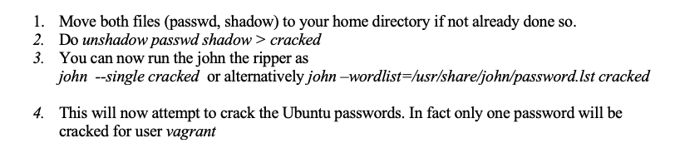

***ANS:***

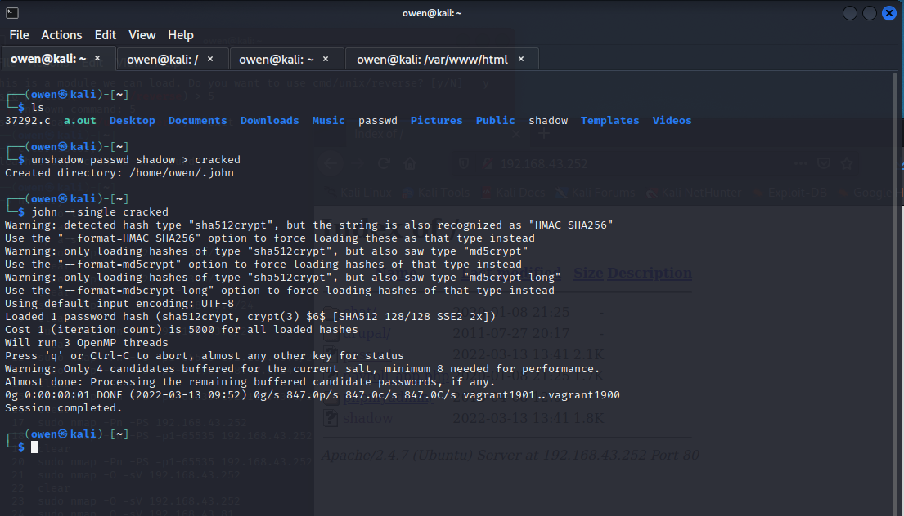

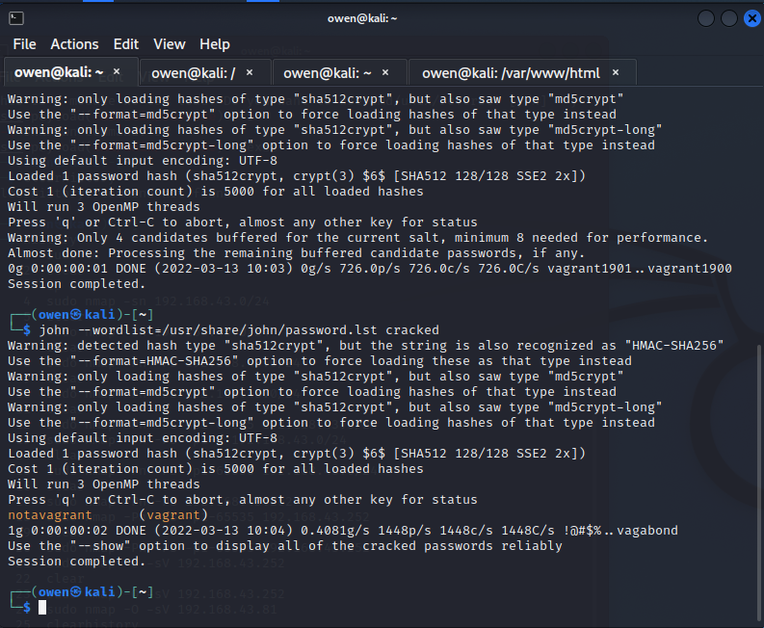

# Task 5 – Login into Ubuntu Metasploit

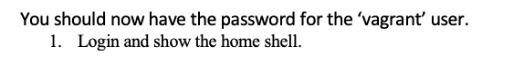

**ANS:**

**Username: vagrant Password: notavagrant**

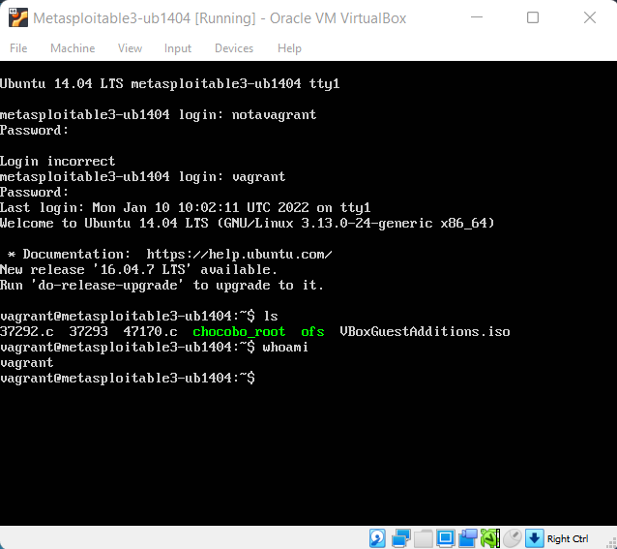



**ANS:**

**Files and directories in the “vagrant” home directory**

**37292.c, 37293, 47170.c, chocobo_root, ofs, VBoxGuestAdditions.iso**

**Image below:**

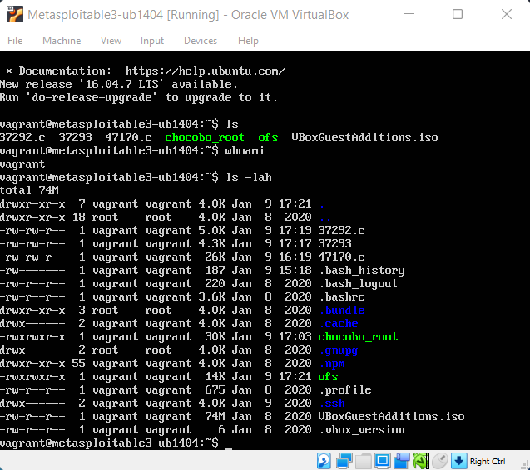

# Task 6 - MAPPING TO ATT&CK

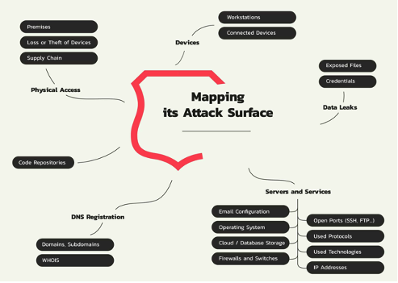

# Definition:

The mapping to attack can be defined as any attacks that take use of weaknesses in network setups or network protocols directly. 'ATT&CK' is an authoritative method to categorize and read challenger methods and recognize they're resolved. It may be used to enhance, test, and test your danger pursuing and recognising energies.

# Tactics, techniques, and sub-techniques:

The goal of an ATT&CK practice or sub-practice is represented through tactics. A competitor, for example, may compel absence in order to get access to your system's documentation.

• Techniques describe how an opponent achieves his or her goal. A adversary, for example, may scrapheap identifications to get record access to your system.

• Sub-methods provide a more detailed description of the performance a challenger used to achieve their goal. For example, a challenger can use the Resident Safety Expert Confidences to force scrapheap identification.

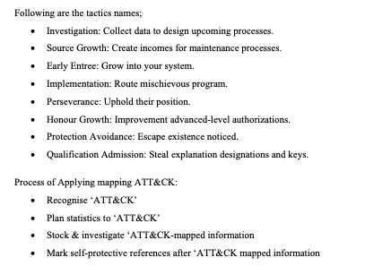

There are many different ways an attacker can exploit an organisations network, through session hijacking, SQL injection and much more. As an IT Security analyst, it is evident that attackers are now becoming more sufficient with their attacks. It is vital for organisations to never take what they have for grated because one little mistake can cause significant damage as we have seen throughout the years with cyber security attacks.

# Task 7 - ATT&CK Technique Countermeasure

The MITRE ATT&CK framework provides a model for cyber adversary behaviour, representing the many stages of an adversary's attack lifecycle as well as the platforms they are known to target. It is critical to identify the dangers, weaknesses, and significance of those threats to facility-related control systems in order to protect a network organisation [4]. MITRE ATT&CK illustrates a variety of strategies that an opponent may employ, but it falls short of providing significant guidance on how the adversary might combine these approaches to achieve their objectives [5].

## ATT&CK Matrix:

The "ATT&CK Matrix" depicts the relationship between tactics, techniques, and sub-methods. For example, beneath the Determination technique (the challenger's goal – to survive in the targeted environment), there is a list of ways such as "Take-over Implementation Movement," "Pre-OS Moonboot," and "Arranged Job/task." Each of them is a single tactic that opponents might employ to achieve the goal of endurance. A collection of techniques utilized by challengers to accomplish a definite neutral is known as the mapping to attack milieu. In the ATT&CK Environment, these goals are referred to as strategies. The goals are presented in a logical order, starting with an investigation opinion and ending with an exfiltration or "influence" goal.

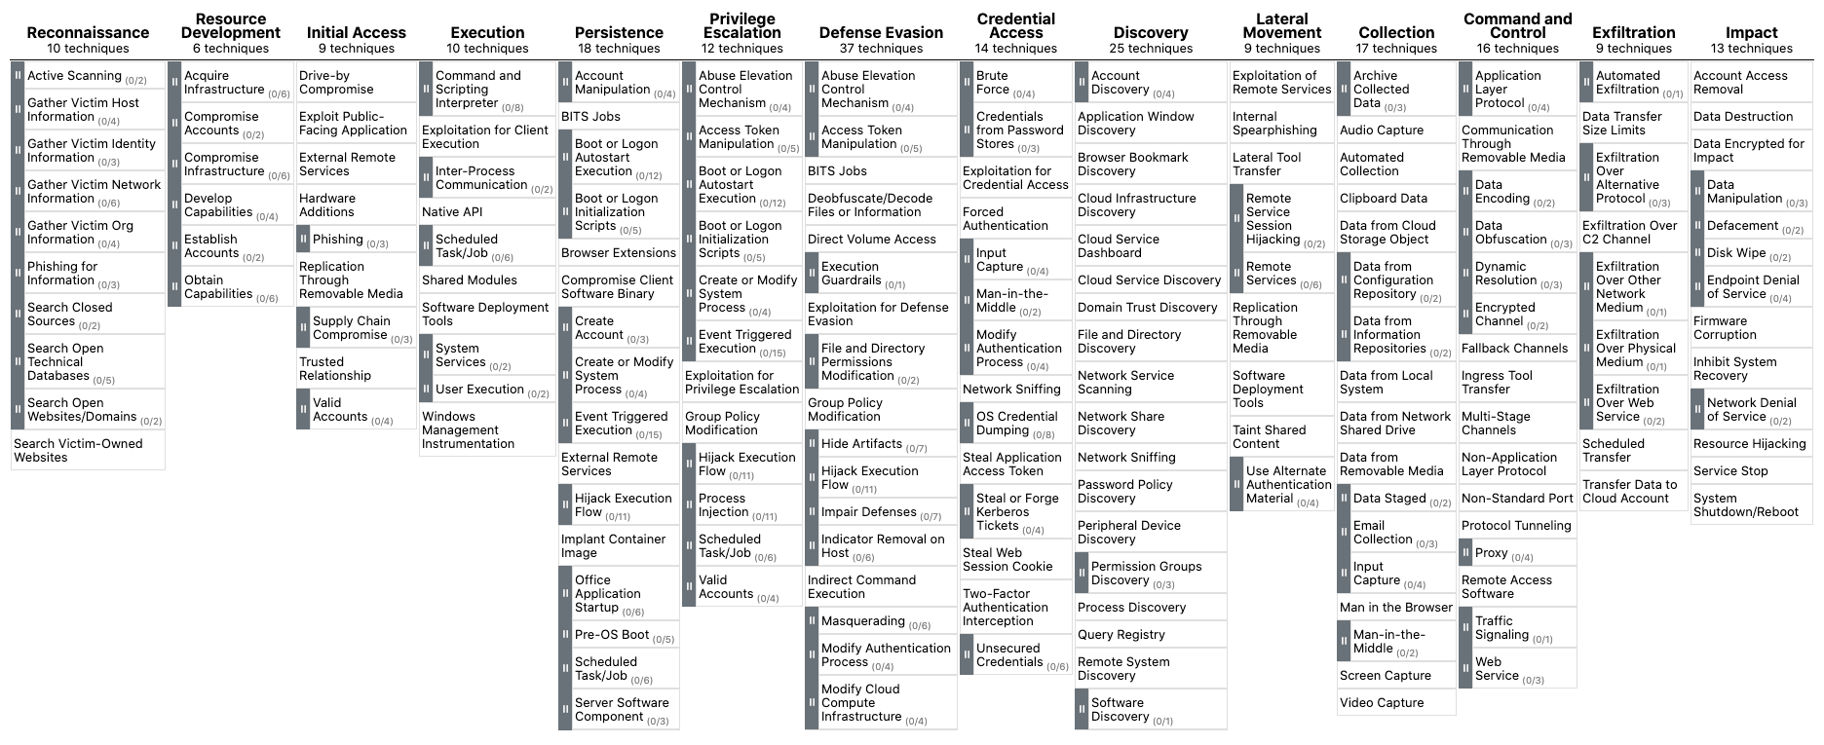

*Source: MITRE ATT&CK for Enterprise, 2020*

Also, certain ways may be broken down into sub-techniques that specify how those activities can be carried out in more detail. For example, 'Pre-OS Boot' contains '3' sub-techniques that include 'Boot kit,' Constituent Firm-ware, and Scheme Firm-ware to a label that describes how persistence is achieved before to occupied scheme installation.

Following are ATT&CK Tactics and 2 techniques and their countermeasures:

Threat-informed defence:

By focusing on establishments that could be considered as known intimidations and then challenging safety panels alongside challenger activities like those sketched in the 'MITRE ATT&CK,' a threat-informed defence strategy may help address this problem. Squads have enhanced numbers and understandings of their database performance over time by relentlessly attacking barriers.

Reconnaissance

Comprises tactics that involve opponents fervently or indifferently meeting facts that may be utilised to provide direction. This information might include details on the target company, organization, or employees. This information can be used by the challenger to help in subsequent phases of the opponent's existence, such as strategizing and executing Early Admission, determining and managing post-cooperation items, and determining and managing additional Investigation battles.

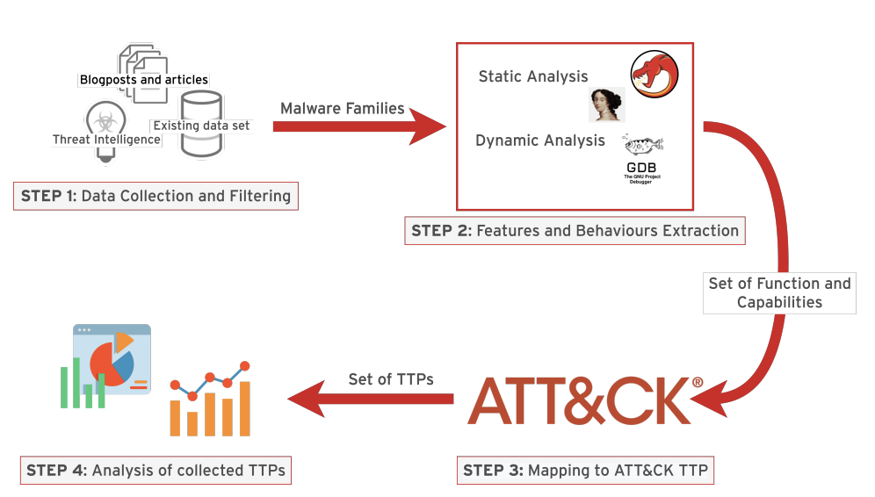

Methodology Process

# Conclusion

In conclusion, completing the given tasks has been extremely beneficial in understanding how penetration testing is used with both Kali and Metasploit. Completing the following tasks Network Scanning, Exploiting the unreal IRC Server, Gaining root access, Cracking the passwords, Logging into ubuntu Metasploit, Mapping to Att&ck and Att&ck Technique Countermeasures has broadened my knowledge and enhanced my skillset significantly. Throughout this process, I hit many road blocks but looking back this was normal as I had to overcome it in order to reach my goal of completing the tasks successfully. I found this assignment to be both extremely challenging and rewarding at times. For example, cracking the passwords. It's easy to tell how concerned they are about security. It allows you to understand if an organisation takes their security important of not. This skill is extremely important for pen testers and something I will take away from this assignment.

Additionally understanding and utilising Metasploit is a crucial skills to know in order to be a successful penetration tester. It’s vital to understand and apply all of these technical skills in the IT security industry.

# References

K. R. Choo, "A Cloud Security Risk-Management Strategy," in IEEE Cloud Computing, vol. 1, no. 2, pp. 52-56, July 2014, doi: 10.1109/MCC.2014.27.

T. Mather, S.Kumarswamy, S. Latif, Cloud Security and Privacy: An Enterprise Perspective on Risks and Compliance, O'Reilly Media, 2009

W. Zhu and C. Lee, "Internet security protection for IRC-based botnet," 2015 IEEE 5th International Conference on Electronics Information and Emergency Communication, 2015, pp. 63-66, doi: 10.1109/ICEIEC.2015.7284488.

R. Kwon, T. Ashley, J. Castleberry, P. Mckenzie and S. N. Gupta Gourisetti, "Cyber Threat Dictionary Using MITRE ATT&CK Matrix and NIST Cybersecurity Framework Mapping," 2020 Resilience Week (RWS), 2020, pp. 106-112, doi: 10.1109/RWS50334.2020.9241271.

R. Al-Shaer, J. M. Spring and E. Christou, "Learning the Associations of MITRE ATT & CK Adversarial Techniques," 2020 IEEE Conference on Communications and Network Security (CNS), 2020, pp. 1-9, doi: 10.1109/CNS48642.2020.9162207.